EYFS | Term 1 |  | Term 2 |  | Term 3 |  |  | Term 4 | Term 5 |  | Term 6
Topic | This is me |  | Space |  | Pirates |  |  | Heroes | Traditional tales |  | Our planet
Big Question | How can I build positive relationships? |  | What is it like in space? |  | What do pirates need to know? |  |  | What makes someone a hero? | Can you tell the same story in different ways? |  | What can I discover?
Texts | 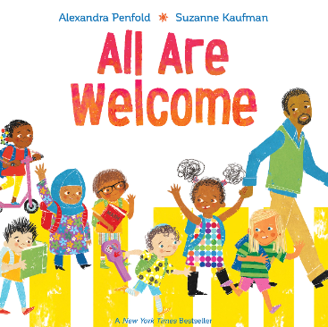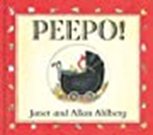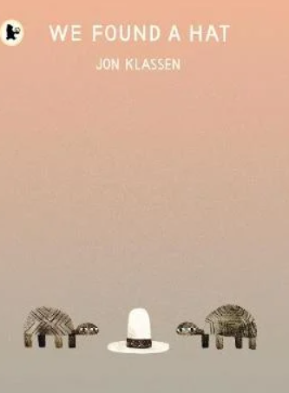  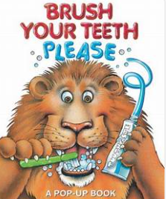  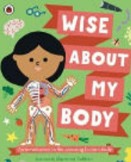 |  | 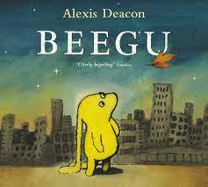  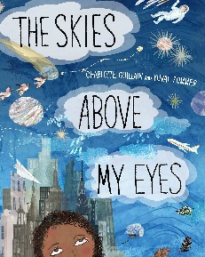  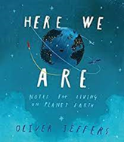 |  | 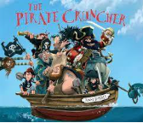  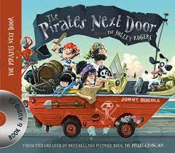  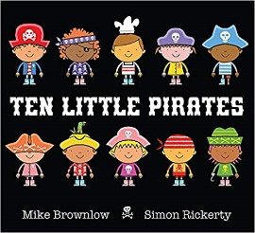  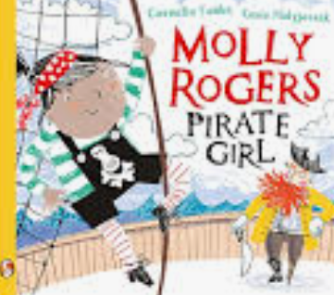 |  |  | 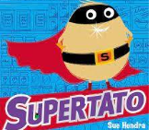  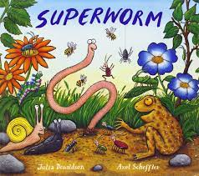  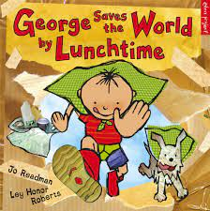  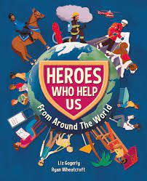 | 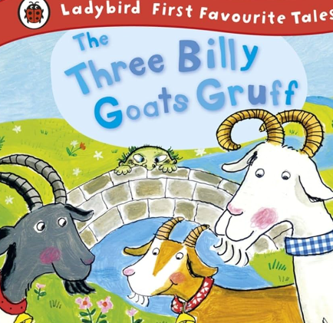  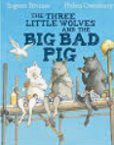  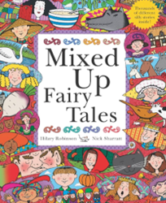 |  | 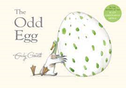  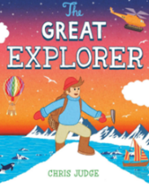  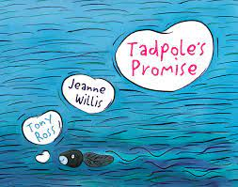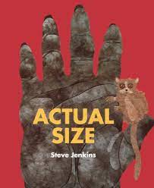  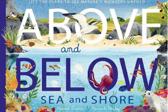
Performance pieces  Linked to: Birth to 5 matters: Speaking with expression, with a clear voice, using volume, pitch and intonation, to communicate and support meaning. | Story:  Conkers |  | Poem:  Snowball by Shel Silverstein |  | Story:  Pesky Pirates |  |  | Poem:  Hero | Story:  Little piggy Rap |  | Poem:  Five little seeds
Visits and Visitors | Church visit for Harvest festival |  | Pantomime  Carol singing at:  Esmere Gardens Nursing Home and Oak Tree Mews Care Home |  | Mother’s Day |  | Local visit: Fire station |  | Sandfield farm and forest school | Zoo Lab
Pupil Promise:  Acts of Kindness | People who help us in school |  | Carol singing |  | RSPB bird watch and making bird feeders |  | People who help us in the community |  | People who help us at home | Littler picking
Person |  |  | Stephen Hawking  _Know that Steven Hawking’s believed that you should always be curious. |  |  |  | Mother Teresa  _Know that Mother Teresa helped people who were poor, sick, or lonely. She showed kindness to everyone. |  |  | David Attenborough  _-Know that Sir David Attenborough has shared his knowledge to inspire others to care about nature.
English | Phonics  Autumn 1  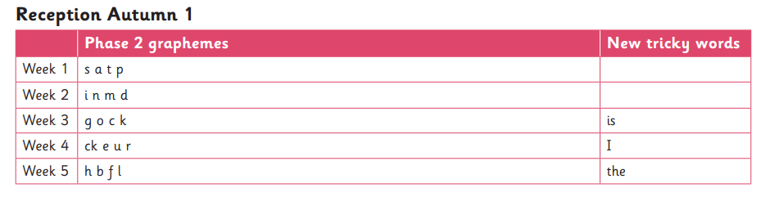  Autumn 2  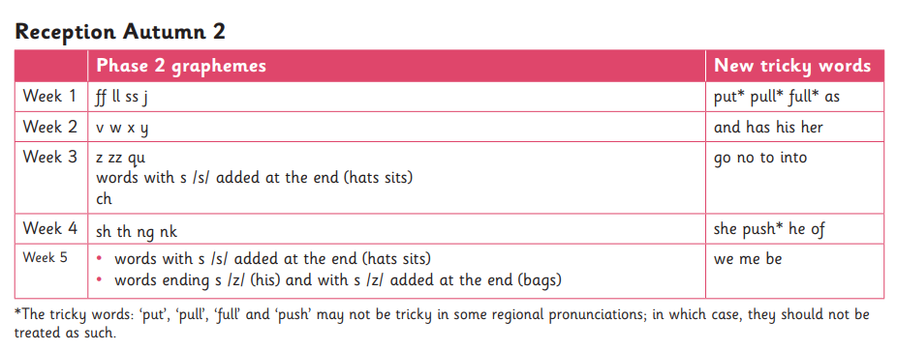  Handwriting  Begin to form lower case letters. (Start with an emphasis on the correct place to start and stop for: c o d g s  I can copy my name  I can write my name (without copying)  Grammar and Punctuation  Begin to segment a word  Spelling/Recognition  s a t p  i n m d  g o c k  ck e u r  h b f l  ff ll ss j  v w x y  z zz qu  ch sh th ng nk |  |  |  | Phonics  Spring 1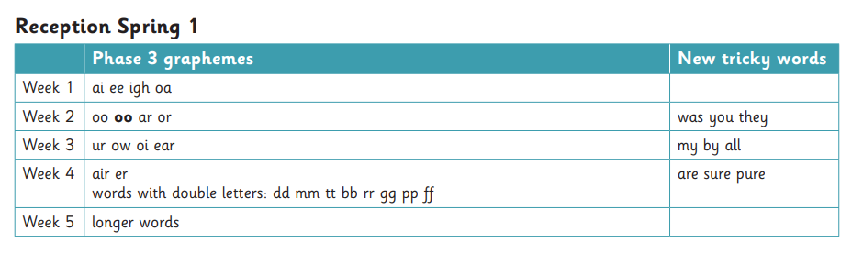  Spring 2  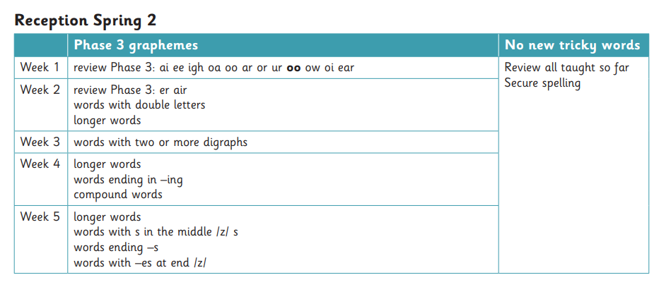  Handwriting  Sit at a table properly, use a hand to hold my book and hold my pencil correctly  Begin to form lower case letters correctly, starting and finishing in the right place  a b c d e f g h i j k l m n o p q r s t u v w x y z  Beginning to use finger spaces between words  Planning, Composition and Editing  Copy the correct grapheme  Recall correct grapheme (without coping it)  Think, say and remember a caption  Read a caption by putting my finger under each word checking it makes sense. Add missing sounds with support.  Grammar and Punctuation  Write a simple (cvc) caption.  Spelling/Recognition  ai ee igh oa  oo oo ar or  ur ow oi ear  air er  I can begin to recognise capital letters  A B C D E F G H I J K L M N O P Q R S T U V W X Z Y |  |  |  | Phonics  Summer 1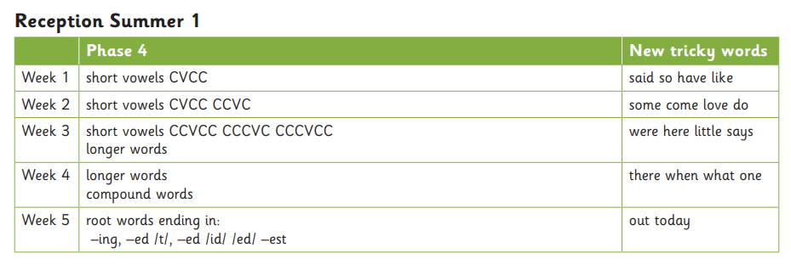  Summer 2  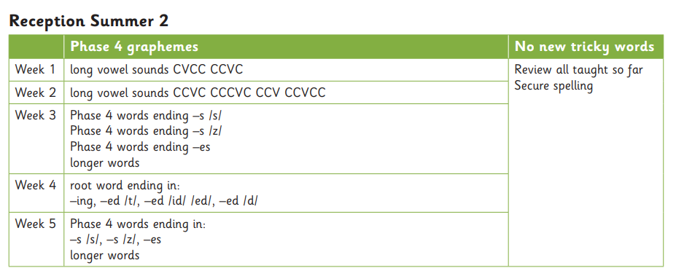  Handwriting  Majority of letter are formed correctly, starting and finishing in the right place.  Many letters sit on the line.  Some tall letters (ascenders) touch the line above. Some (descenders) fall below the line.  Use many short letters.  Form most uppercase letters correctly, starting and finishing in the right place.  A B C D E F G H I J K L M N O P Q R S T U W X Y Z  Planning, Composition and editing  Think, say and remember a caption.  Think say and remember a sentence.  Say and remember a sentence/caption that starts with a given time word.  (First, Next, Finally).  Correct any missing capital letters with support.  Grammar and Punctuation  Independently write a caption with finger spaces.  Write a sentence with a full stop or exclamation mark.  Write a sentence starting with a time word and end with a full stop.  Spelling  I the is  as no to  go and was  my
Maths  Daily Fluency/Mastering Number (10–15 mins): subitising, composition, recall of bonds, reasoning.  Focus Sessions (WRM small steps): taught through practical activities with manipulatives.  Continuous Provision: maths embedded in play (role play shops, outdoor counting games, construction, etc.).  Maths Talk: use stem sentences and reasoning prompts throughout (e.g., “I know it’s 7 because…”). | White Rose Focus  - Just Like Me  - Matching, sorting, comparing amounts.  - Comparing size, mass, and capacity.  - Exploring pattern.  - It’s Me 1, 2, 3  - Representing 1, 2, 3.  - Comparing 1, 2, 3.  - Composition of 1, 2, 3.  - Circles and triangles.  - Positional language.  - Light and Dark  - Numbers to 5.  - Comparing groups within 5.  - Shapes with 4 sides.  - Night and day.  NCETM Mastering Number Links  - Daily subitising within 3, moving to 5.  - Counting songs, rhymes, and games.  - Comparing and ordering quantities using stem sentences (“2 is fewer than 3”).  - Using 5-frames for early composition.  Autumn 1 (7 weeks) – Settling, early number sense  Week 1: Matching, sorting, comparing objects (WRM Just Like Me) + MN: subitise to 3.  Week 2: Comparing amounts, size, mass, capacity + MN: comparing “more / fewer.”  Week 3: Pattern making + MN: recognising arrangements of 1–3.  Week 4: Numbers 1, 2, 3 (WRM It’s Me 1,2,3) + MN: subitising to 4.  Week 5: Comparing 1, 2, 3 + MN: using stem sentences “2 is fewer than 3.”  Week 6: Composition of 1, 2, 3 + MN: 5-frame introduced.  Week 7: Circles, triangles, positional language + MN: exploring conservation of number.  Autumn 2 (7 weeks) – Numbers to 5  Week 1: Numbers 4 and 5 (WRM Light & Dark) + MN: subitising to 5.  Week 2: Comparing numbers within 5 + MN: building fluency with “1 more/1 fewer.”  Week 3: Composition of 4 and 5 + MN: exploring different partitions of 5.  Week 4: Shapes with 4 sides + MN: arrangement spotting.  Week 5: Positional/directional language + MN: structured subitising within 5.  Week 6: Night/day measures + MN: counting on/back from 5.  Week 7: Consolidation week (review all to 5). |  |  |  | White Rose Focus  - Alive in 5  - Introducing zero.  - Comparing numbers to 5.  - Composition of 4 and 5.  - Compare mass and capacity.  - Growing 6, 7, 8  - Making 6, 7, and 8.  - Composition of 6, 7, 8.  - Combining 2 groups.  - Length and height.  - Time (sequencing events).  - Building 9 & 10  - Counting to 9 and 10.  - Comparing numbers to 10.  - Bonds to 10.  - 3D shape.  - Pattern (complex).  NCETM Mastering Number Links  - Secure subitising within 5.  - Using 10-frames to explore numbers to 10.  - Doubles and near doubles.  - Early addition and subtraction through composition and comparison.  - Vocabulary: “more,” “fewer,” “equal.”  Spring 1 (6 weeks) – Zero, composition, and comparison  Week 1: Introducing 0 (WRM Alive in 5) + MN: empty set, “nothing there.”  Week 2: Comparing numbers to 5 + MN: bonds within 5 secure.  Week 3: Composition of 4 and 5 + MN: instant recall of 5.  Week 4: Mass and capacity + MN: reasoning with equal and unequal sets.  Week 5: Counting 6, 7, 8 (WRM Growing 6,7,8) + MN: 10-frame used for 6–8.  Week 6: Making 6, 7, 8 + MN: doubles and near doubles to 5.  Spring 2 (6 weeks) – Numbers to 10, shape, time  Week 1: Composition of 6, 7, 8 + MN: bonds to 6.  Week 2: Combining two groups + MN: addition through real contexts.  Week 3: Comparing length/height + MN: using vocabulary longer/shorter.  Week 4: Counting 9, 10 (WRM Building 9 & 10) + MN: bonds to 10.  Week 5: Comparing numbers to 10 + MN: reasoning with “more/less than 10.”  Week 6: 3D shape, repeating/complex patterns + MN: subitising beyond 5 in patterns. |  |  |  | White Rose Focus  - To 20 and Beyond  - Building numbers beyond 10.  - Counting patterns beyond 10.  - Spatial reasoning: match, rotate, manipulate.  - First, Then, Now  - Adding more.  - Taking away.  - Spatial reasoning: compose and decompose.  - Find My Pattern  - Doubling.  - Sharing and grouping.  - Odd and even.  - Spatial reasoning: visualise and build.  - On the Move  - Deepening understanding of patterns and relationships.  - Spatial reasoning: mapping.  NCETM Mastering Number Links  - Securing bonds to 5 and 10.  - Rapid recall of doubles up to 5+5.  - Exploring odds and evens informally.  - Reasoning with numbers to 20.  - Preparing for KS1: counting on/back, bridging through 10.  Summer Term 1 (6 weeks) – Beyond 10, adding/taking away  Week 1: Numbers beyond 10 (WRM To 20 and Beyond) + MN: teen numbers explored with tens frame.  Week 2: Counting patterns beyond 10 + MN: count in 2s, 5s informally.  Week 3: Spatial reasoning – match, rotate, manipulate + MN: reasoning about arrangements.  Week 4: Adding more (WRM First, Then, Now) + MN: counting on strategy.  Week 5: Taking away + MN: counting back strategy.  Week 6: Compose and decompose shapes + MN: recognising part/whole in arrangements.  Summer 2 (7 weeks) – Pattern, doubling, sharing, KS1 prep  Week 1: Doubling (WRM Find My Pattern) + MN: rapid recall doubles to 5+5.  Week 2: Sharing and grouping + MN: equal groups practical exploration.  Week 3: Odd and even + MN: exploring pairs/leftovers.  Week 4: Visualise and build (spatial reasoning) + MN: problem-solving with patterns.  Week 5: Deepening understanding of patterns and relationships (WRM On the Move).  Week 6: Mapping and directional language + MN: embedding positional reasoning.  Week 7: Consolidation / Transition to Year 1 – bonds to 10 secure, numbers beyond 20 explored.
Science  Understanding the World: “children to make sense of their physical world…increase their knowledge and sense of the world around them. | Humans  _Describe five physical features of a member of their family.  _Know 3 ways to take care of themselves:  Brush teeth, Wash – body and hands , Toileting, Eat/drink water and Exercise  _Know that as a baby I did not have teeth but now I have milk teeth. When I am an adult, I will have adult teeth. | Space  _Know the name of the planet I live on.  _Know that the sun is a burning ball of gas.  _Know that some planets have moons.  _Know that people have gone into space.  _Name some planets. |  |  | Materials  _Be able to sort materials: Metal, Plastic, Cardboard, Glass,  Paper  _Know that some materials can change over time and in different conditions  Wood -rots/Metal - rusts  _Know that some things sink and some things float: Feather/Rock | Light  _Know that the sun is a source of light.  _Know other sources of light including: lamps, torches, candles, and fire.  _Know that a shadow is formed when an object blocks the light.  _Know that rain and light make a rainbow. |  |  | Sound  _Know that we hear sounds with our ears  _Identify the source of a sound:  Bird song, Weather, Transport  _Know that sounds are made when things move or vibrate (“things have to move to make a sound”). |  |  | Living things and their habitats  _Know that plants need light from the sun and water to grow.  _Know that different trees have different shape leaves.  _Name each phase of a frog’s growth. (Life cycle – Frogs)
 | STEM  Soggy cereals |  | STEM  Milky northern lights |  | STEM  Pipe cleaner push and pull |  |  | STEM  Eggsperiment | STEM  Billy goat gruff bridges |  | STEM  Terrific tunes
 | Season – Autumn  - Know that it starts to get colder in Autumn.  - Know that some trees lose their leaves in Autumn.  - Know that hedgehogs hibernate |  | Season – Winter  - Know that it is cold in winter.  - Know that ice melts |  |  |  |  | Season – Spring  - Know that it starts to get warmer in Spring. |  |  | Season – Summer  - Know that it is hotter in Summer.
RE | F3. How might people in Gloucestershire show they belong together?  Sharing baby photos  Children share photographs of past celebrations. |  | F2. Why is Christmas special to Christians? |  | F1. Why is God so important to Christians? |  |  | F4. What special times do people celebrate and why might these times be very important? | F6. What stories are important in our school community/ local area and why? |  | F5. Which places are special for people living in Gloucestershire and why?
Spirituality | PE  What it feels like to express ourselves with our bodies |  | Literacy  Reflection and shared emotions about books |  | Music  What types of music make you relaxed/calm |  |  | History  How can we help others learning from the past | Art  Can we use art to express yourself |  | Science  What does it feel like to feel the warm sunshine in summer
 | WOW  - Starting big school  - New friends/toys  OW  -Leaving parents/carers  - Feeling lost/overwhelmed |  | WOW  -Being healthy  OW  -Being poorly |  | WOW  -What is treasure  OW  - When things go missing |  |  | WOW  -How does helping others make you feel  OW  -Being misunderstood | WOW  - Feelings when working as a team  OW  -Feelings when working as a team |  | WOW  - Achievements  OW  - When things are difficult/ can’t do something
History | In my past  _Know that things that have happened before now are in the past  _Know that babies grow into toddlers, then children.  _Know that as we grow older, we change and learn to do new things  _Know that my Grandparents are my Mum and Dads parents.  _Know which objects are from the past and which are modern. (toys / home artefacts) |  | Space exploration  _Know that Neil Armstrong was the first person to walk on the Moon.  _Know that Valentina Tereshkova was the first woman in space.  _Know that people in the past used different things to influence the world today (eg. Space shuttles). |  | Maps  _Know where I live  _Know some of the features of my immediate environment  _Know the name of my school  _Know what a map is  _Know that maps contain simple information about places  _Know simple directions: near/far, left/right, up/down.  -Know some of the people who work in my community and what they do. |  |  | Weather Patterns  - Know how to observe and describe daily weather: sunny, rainy, windy, snowy.  _Know how the environment changes during each season.  _Know how to describe how weather feels (hot, cold, wet, dry).  _Know how to record weather using simple charts or drawings. | Stories from the past  _Traditional tales are old stories that people have told for many years.  _Know that homes, clothes, and tools in traditional tales were often different from today.  _Know how to sequence events: first, next, last.  _Know that people in lived differently in the past. |  | The world around us  _Know about the differences between their local geography and that of other extreme geographical locations (desert, arctic and ocean).  _Knows how to identify natural features in their local area.  _Knows about different places in the world: countries, continents, oceans
Geography

Music: Charanga | Me! |  | My Stories |  | Everyone! |  |  | Our World | Big Bear Funk |  | Reflect, Rewind and Replay
Art | Kapow  Drawing: Marvellous marks |  |  |  |  |  |  | Kapow  Sculpture and 3D: Creation station |  |  | Kapow  Painting and mixed media: Paint my world
DT |  |  | Kapow  Cooking and Nutrition – Christmas cakes |  | Kapow  Structures: Boats |  |  |  | Kapow  Textiles: Bookmarks
PSHE: Jigsaw | Being me in my World |  | Celebrating Differences |  | Dreams and Goals |  |  | Healthy Me | Relationships |  | Changing Me
PE: | PPE scheme  First PE  Multi skills  Fine Motor  Dough Disco |  | PPE scheme  Gymnastics  Fitness and fun  Fine Motor  Dough Disco |  | PPE scheme  Olympic Dance  Fine Motor  Dough Disco |  |  | PPE scheme  Football fun  Fairy tale dance  Fine Motor  Dance write | PPE scheme  Outdoor adventure  Enjoy a ball  Fine Motor  Dance write |  | PPE scheme  Athletics  Tennis Fun  Fine Motor  Dance write

