Year 1 and 2 | Term 1 | Term 2 | Term 3 | Term 4 | Term 5 |  | Term 6
Topic | Toys | Great Fire of London | Moreton | Fossil hunters | Our planet |  | Plants
Big Question | Have children always played with toys? | Why is London special? | Where do I live? | Who found the first fossil? | Can we name our animals? |  | How do plants grow?
English writing Texts | 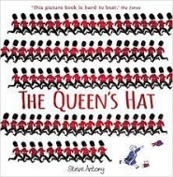  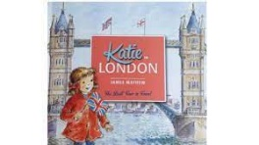 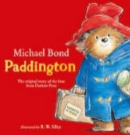Katie in London The Queen’s Hat Paddington at the Tower Paddington at the Palace | 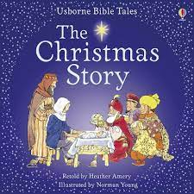  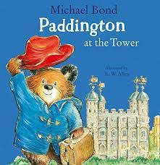  Paddington Bear cont’d – instructions The Snowman The Christmas story | 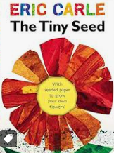  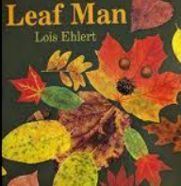  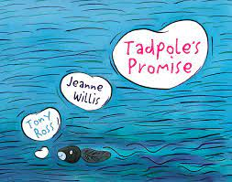 | 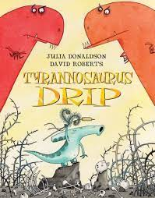  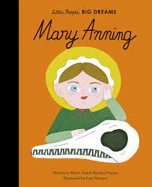  Stone Girl: Bone Girl text.  Factual recount – Mary Anning Diary writing – Mary Anning Tyrannosaurus …. Drip | 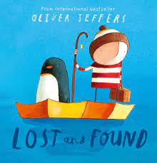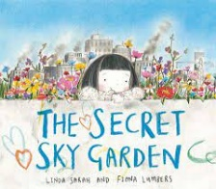  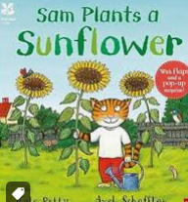  Lost and Found  The secret sky garden  Riddles |  | 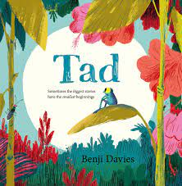  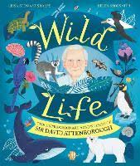  Tad Explanation writing – Tadpoles (lifecycles) Wild life: The extraordinary adventures of David Attenborough.
Visits and Visitors | Batsford Arboretum |  | Natural History Museum |  | Garden Centre
Science | Seasonal changes (Yr 1)  observe changes across the four seasons  observe and describe weather associated with the seasons and how day length varies. |  | Plants (Yr 1)  identify and name a variety of common wild and garden plants, including deciduous and evergreen trees  identify and describe the basic structure of a variety of common flowering plants, including trees. |  | Animals including humans (Animals) (Yr1)  identify and name a variety of common animals including fish, amphibians, reptiles, birds and mammals  describe and compare the structure of a variety of common animals (fish, amphibians, reptiles, birds and mammals including pets)  identify and name a variety of common animals that are carnivores, herbivores and omnivores | Plants (Yr 2)  observe and describe how seeds and bulbs grow into mature plants  find out and describe how plants need water, light and a suitable temperature to grow and stay healthy
RE | 1.1 What do Christians believe God is like? | 1.2 Why does Christmas matter to Christians and how do people celebrate it? | 1.7 What is it like to be brought up in a Muslim home in the UK today? | 1.5 What is it like to be brought up in a Muslim home in the UK today? | 1.9 How do stories and art express worldviews? (Christian, Muslim, Hindu, NR/Humanist)
History | Toys  - Order and sequence some familiar objects (toys). -Use some everyday terms about the passing of time such as 'a long | Fire of London—Samuel Pepys  - Identify some of the basic ways in which the past can be represented including Samuel Pepys’ diary.  -Ask and answer question about the past through observing and handling a range of sources – asking why/what/who/how/where questions to find answers. - Retell some events from beyond their living memory which are significant nationally (The Great Fire of London). - Demonstrate simple historical concepts and events through role-play, drawing and writing. - Understand why events happened and what happened as a result (changes to buildings in London). | Local Geography  -Use aerial photographs and plan perspectives to recognise landmarks and basic human and physical features of Moreton. -Devise a simple map of Moreton and use and construct basic symbols in a key. - Use simple compass directions (North, South, East and West) and locational and directional language [for example, near and far; left and right], to describe the location of features and routes on a map.  Focus: human and physical features. Maps. Compass points etc., | Mary Anning Demonstrate awareness of the lives of significant individuals in the past who have contributed to national and international achievements (Mary Anning). -Ask and answer questions about the past through observing and handling a range of sources – asking why/what/who/how/where questions to find answers. - Talk about what/who was significant in simple historical accounts. | Jurassic landscape features  - Name, locate and identify characteristics of the four countries and capital cities of the United Kingdom and its surrounding seas and the position of the Jurassic coast. - Use basic geographical to key physical features, including: beach, cliff, coast, sea, ocean. -Use basic geographical vocabulary to refer to key human features, including: city, town, village, port, harbour and shop.  United Kingdom. -Use basic geographical vocabulary to refer to key physical features, including season and weather. - Identify the location of hot and cold areas of the world in relation to the Equator and the North and South Poles. |  | David Attenborough  - Demonstrate an awareness of the lives of significant individuals in the past who have contributed to national and international achievements (David Attenborough). - Describe special or significant events. - Talk about what/who was significant in simple historical accounts. - Use sources to answer and ask simple questions about the past.
Geography | Weather/ Seasons -Identify seasonal and daily weather patterns in the United Kingdom. This will be completed in the Science
Computing:  Purple Mash | Introduction to Purple Mash (Y1)  Creative computing (Y1)  Creating pictures (Y2) |  | Spreadsheets (Y2)  Animated stories (Y1) |  | Coding (Y1)  Coding (Y2)
Music: Charanga | Hands, Feet, Heart  Edward Grieg In the hall of the mountain king | Ho Ho Ho  Tchaikovsky Nutcracker | I Wanna Play In A Band  Joseph Haydn Trumpet Concerto in the 3rd Movement | Zootime  Aaron Copland Rodeo Hoe Down | Friendship Song  Hans Zimmer Earth |  | Reflect, Rewind and Replay  Richard Wagner Ride of the Valkyries
Art |  |  | Painting and mixed media  Painting, collage Natural forms (Plan Bee) |  | Sculpture and 3D: Clay  Clay House Tile (Kapow) |  | Craft and Design Henry Rousseau (Plan Bee) Shoe Box Models - world
DT | Mechanisms:  Making a moving-story book (Kapow) | Mechanisms  Wheels and Axels: Fire Engines (Kapow) |  | Textiles: Puppets (Kapow)
PSHE: Jigsaw | Year 2  Being me in My World | Year 2  Celebrating Difference | Year 2  Dreams and Goals | Year 2  Healthy Me | Year 2  Relationships |  | Year 1  Changing Me
PE | Ball Skills  Gymnatics | Ball Skills  Great Fire of London dance | Rugby funs  Outdoor Adventure Activities | Ball Games  Multi Skills | Kwik Cricket  Athletics |  | Tennis  Social Dodgeball
Spirituality | The historical ‘wows’ for children throughout the different time periods receiving a toy.  The geographical ows, wows nows of nature and the times that weather gives us eg, thunderstorms  English: How we can enjoy stories as a tool for headspace and reflection.  Science: Spirituality of nature, looking specifically at the 4 seasons.  DT: What motivates designers to create moving parts? | The historical ‘ow’ moments – reflections of the tricky times for people living in London. Leading to historical ‘wow’ moment that only a few died.  English: How we can enjoy stories as a tool for headspace and reflection.  Science: Spirituality of nature, looking specifically at the 4 seasons.  DT: What motivates designers to create moving parts? | Geographical – the landscape of the Jurassic coast being a reflective areas for many people then and now.  English: How we can enjoy stories as a tool for headspace and reflection.  Science: How animals can be a tool of reflection  Art: Think and reflect on why artists paint what they do. | The historical ow of Mary Anning and how she must’ve felt with her work not being recognised.  English: How we can enjoy stories as a tool for headspace and reflection.  Science: How animals can be a tool of reflection  DT: Reflect on designers | What ows, wows and nows does Moreton and the Cotswolds provide?  English: How we can enjoy stories as a tool for headspace and reflection.  Science: How watching plants can be used as a stop time to think.  Art: How sculptures use their tools to craft images |  | The work of David Attenborough – how nature can give us opportunities to develop our spirituality.  English: How we can enjoy stories as a tool for headspace and reflection.  Science: How watching plants can be used as a stop time to think.  Art: Reflect on the work of Henry Rouseau.
Role Models and Heroes |  | Malala Yousafzai | Andy Goldsworthy | Coldplay | Oliver Jeffers |  | David Attenborough

