Year 3 and 4 | Term 1 | Term 2 | Term 3 | Term 4 | Term 5 | Term 6
Topic | The Ages | Light and Shadows | Mountains and Volcanoes |  | Anglo Saxons and Vikings
Big Question | How did tools change through the ages? | What is the impact of light on daily life? | What is the difference between a mountain and a volcano? |  | Were the Vikings always victorious and vicious?
English Writing Texts | 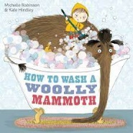  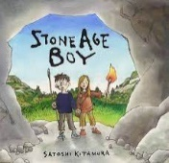  The Stone Age Boy  How to wash a Woolly Mammoth | 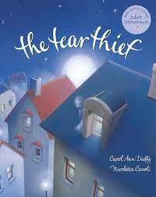  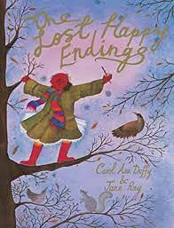  The Tear Thief  The Lost Happy Endings | 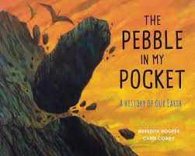  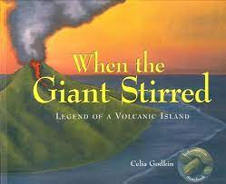  When the giant stirred The Pebble in My Pocket |  | 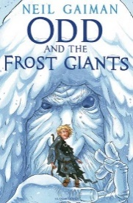  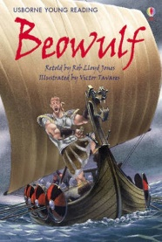  Odd and the Forest Giants Beowulf (hardback short story)
Guided Reading | 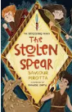  The Stolen Spear | 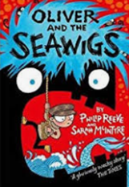  Oliver and the Seawigs | 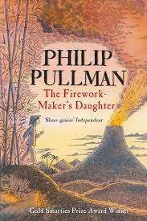  The Firework Marker’s Daughter | 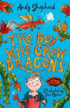  The Boy Who Grew Dragons | 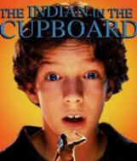  The Indian in the Cupboard | 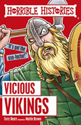  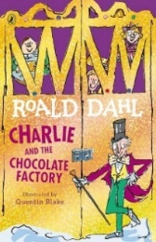  Charlie and the Chocolate Factory
St. David’s Pupil Promise | Year 3 Responsible Tourists  Year 4 Super Scientists
Visits and Visitors | Greystones Nature Reserve, Bourton  Rollright Stones, near Chipping Norton |  | Science Festival Pupil Promise (Year 4)  Possible trip to Oxford Natural History Museum. |  | Hillend Pupil Promise (Year 3)
Science | Animals including humans (Yr 3)  identify that animals, including humans, need the right types and amount of nutrition, and that they cannot make their own food; they get nutrition from what they eat  identify that humans and some other animals have skeletons and muscles for support, protection and movement. | Light (Yr 3)  - recognise that they need light in order to see things and that dark is the absence of light  - notice that light is reflected from surfaces  - recognise that light from the sun can be dangerous and that there are ways to protect their eyes  - recognise that shadows are formed when the light from a light source is blocked by  an opaque object  -find patterns in the way that the size of shadows change. | Rocks (Yr 3)  -compare and group together different kinds of rocks on the basis of their appearance and simple physical properties  - describe in simple terms how fossils are formed when things that have lived are trapped within rock  -recognise that soils are made from rocks and organic matter | Plants (Yr 3)  - identify and describe the functions of different parts of flowering plants: roots, stem/trunk, leaves and flowers  - explore the requirements of plants for life and growth (air, light, water, nutrients from soil, and room to grow) and how they vary from plant to plant  - investigate the way in which water is transported within plants  - explore the part that flowers play in the life cycle of flowering plants, including pollination, seed formation and seed dispersal. | Electricity (Yr 4)  identify common appliances that run on electricity  construct a simple series electrical circuit, identifying and naming its basic parts, including cells, wires, bulbs, switches and buzzers  identify whether or not a lamp will light in a simple series circuit, based on whether or not the lamp is part of a complete loop with a battery  recognise that a switch opens and closes a circuit and associate this with whether or not a lamp lights in a simple series circuit  recognise some common conductors and insulators, and associate metals with being good conductors. | Sound (Yr 4)  identify how sounds are made, associating some of them with something vibrating  recognise that vibrations from sounds travel through a medium to the ear  find patterns between the pitch of a sound and features of the object that produced it  find patterns between the volume of a sound and the strength of the vibrations that produced it  Recognise that sounds get fainter as the distance from the sound source increases.
RE | What might Christians learn from the Old Testament about how to live? | Why is Muhammed important to Muslims today? | Do all Christians believe and behave in the same way? | What do Muslims believe about God and how do they respond? | How and why do people (in three traditions) use ceremonies to show their commitments? | What is the “golden rule” and how might it be put into practice by people from different religious and non-religious world views?
Spirituality | Maths - The wonder of number patterns  English (GR) What inspired you in this text?  How did a character cope with a challenge in life?  Maths - What cannot be accurately counted? For example, the difference an act of kindness makes.  MFL-What does it feel like to genuinely communicate with someone in a new language?  His- Which stories tell historical wows? Which stories tell historical ows? What lessons for future decisions and choices do they provide?  Sci- Delight in discovering how things work. |  | English (GR) What inspired you in this text?  How did a character cope with a challenge in life?  Geog- The wow of physical geography.  Sci- Opportunities to linger longer on the wonder!  Art- How do you celebrate and respect different responses to art? |  | Maths - What cannot be measured? For example, love  English (GR) What inspired you in this text?  How did a character cope with a challenge in life?  Sci- What questions cannot be answered by science?  His- Which stories tell historical wows? Which stories tell historical ows? What lessons for future decisions and choices do they provide?
History | Changes in Britain from the Stone Age to the Iron Age  - Use dates to sequence events from across different periods of History (Stone Age to Iron Age). - Identify changes within the Stone Age including tools, settlements and monuments. - Use a range of sources to find out about life during the Bronze Age and organise relevant historical information to present in a range of ways. -Use a range of sources to Explore links and contrasts within and across different periods of time (how tools changed from the Stone Age to the Bronze Age and how this impacted daily life). | Re-visit Oceans and continents  Biomes and climate zones  -Locate and name the continents and oceans on a World Map. -Identify the position and significance of Equator, N. and S. Hemisphere, Tropics of Cancer and Capricorn. -On a world map, locate areas of similar environmental regions -Describe and understand key aspects of Physical geography, including: climate zones and biomes (link to climate change and its effect on the oceans and marine biomes) | Mountains and volcanos  OS Map Skills  -Locate and name the continents on a world map and use this to help locate the world’s significant mountain ranges and volcanoes. - Identify the position and significance of Equator, N. and S. Hemisphere. - Describe and understand key aspects of Physical geography, including an introduction to Volcanoes and earthquakes linking to Science: rock types. -Identify the highest mountains in the world and compare them with the UK. - Use maps, atlases, globes and digital/computer mapping (Google Earth) to locate countries and describe features studied. - Learn the eight points of a compass, 2 figure grid reference, some basic symbols and key (including the use of a simplified Ordnance Survey maps) to build their knowledge of the United Kingdom. • Use fieldwork to observe and record the human and physical features in the local area using a range of methods, including sketch maps, plans and graphs. |  | Anglo Saxons and Vikings (crime and punishment)  - Use some dates and historical terms when sequencing events relating to Britain’s settlement by the Anglo-Saxons and Scots. -Use artefacts and a range of sources to find out about and compare Anglo Saxon and Viking daily life/religious beliefs. -Use primary and secondary sources to explore the Viking and Anglo-Saxon struggle for the Kingdom of England. -Explore how the Viking invaders were viewed by the Anglo Saxons and recognise that different versions of past events may exist. - Use sources to address historically valid questions, ‘Can King Alfred be viewed as Great’. | Types of settlements linked with Anglo Saxons and Vikings  - Locate and name the countries making up the British Isles, with their capital cities. - Identify types of settlements in Early Britain linked to History. Why did early people choose to settle there? (Anglo Saxons and Vikings). • Compare early settlements with types of settlements in modern Britain: villages, towns, cities.
Geography
Computing:  Purple Mash | Year 3: Unit 3.1  Coding  Unit 3.2  Online safety  Unit 3.3  Spreadsheets |  | Year 3:  Unit 3.4  Touch Typing  Unit 3.5  Email (including email  safety)  Unit 3.6 Branching Databases |  | Year 3:  Unit 3.7  Simulations  Unit 3.8  Graphing  Unit 3.9  Presenting (with  Microsoft PowerPoint  or Google Slides)
Music: Charanga | Year 3  Let Your Spirit Fly  Edward Grieg In the hall of the mountain king | Year 3  Glockenspiel Stage 1  Tchaikovsky Nutcracker | Year 3  Three Little Birds  Joseph Haydn Trumpet Concerto in the 3rd Movement | Year 3  The Dragon Song  Aaron Copland Rodeo Hoe Down | Year 3  Bringing Us Together  Hans Zimmer Earth | Year 3  Reflect, Rewind and Replay  Richard Wagner Ride of the Valkyries
Art | Painting and mixed media Exploring pre-historic art (Kapow) |  | Drawing Landscapes |  | Craft and Design Anglo-Saxon weapon and jewellery making
DT |  | Electrical systems: Torches Identify the difference between electrical and electronic products. Evaluate a range of existing torches and their features, then develop a new functional torch design (Kapow) |  | Food: Eating Seasonally (Kapow) |  | Structures Anglo-Saxon houses
MFL: Primary Languages (French) | A new start | Calendar and Celebrations | Epiphany  Animals | Carnival, colours and playground | Hungry Giant | Going on a picnic!
PSHE: Jigsaw | Year 4  Being in My world | Year 4  Celebrating Difference | Year 4  Dreams and Goals | Year 4  Healthy Me | Year 4  Relationships | Year 3  Changing Me  Year 4  Changing me
PE  Year 3 | Gym - CPD  Real P.e – Netball, basketball, football  Coordination: Footwork  Funs station 10  Multi- ability skill: Personal | Gym - CPD  Real P.e tag gym, tag rugby  Dynamic Balance to agility:  Jumping and Landing  Funs station 6  Multi-ability skill: Social | Real P.e gym, dance  Dynamic Balance on a line  Funs station 5  Multi-ability skill: cognitive | Real P.e rounders, tennis  Coordination:  Sending and receiving  Funs station 8  Multi-ability skill: Creative | Real P.e cricket, rounders, athletics  Agility  Reaction/response  Funs Station 12  Multi-ability skill: Applying physical | Real. Pe cricket, rounders, athletics  Agility  Ball Chasing  Funs station 11  Multi-ability skill: Health and fitness
Year 4 | Gym - CPD  Netball, basketball, football Real P.e  Static balance: one leg  Funs station 1  Multi- ability skill: Personal | Dance, gym  Real P.e  Stactic Balanced: seated  Funs station 2  Multi-ability skill: Social | Netball, basketball, football  Real P.e  Coordination:  Ball Skills  Funs Station 9  Multi-ability skill: cognitive | Tennis, gym  Real P.e  Counter Balance:  With a partner  Funs station 7  Multi-ability skill: Creative | Rounders (Striking and positioning), cricket  Real. Pe  Static Balance  Floor work  Funs station 4  Multi-ability skill: Applying physical | Athletics (Running and throwing), cricket, rounders, tennis  Real P.e  Static balance:  Stance  Funs station 4  Multi-ability skill: Health and fitness

